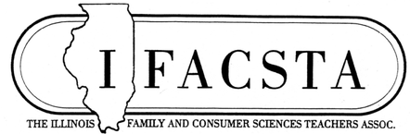
“Come to the IFACSTA Table”
November 13, 2026
The Herrington Inn
15 S River Ln. Geneva, IL 60134

Name Badge Information (Print clearly) First Name __________________________ Last Name___________________________ School______________________________ Mailing Address_______________________ City ________________________________ State______________________Zip_______ Telephone(____)______________________ E-mail_______________________________
Have you attended an IFACSTA conference before?
____Yes ____No

What levels apply to your responsibility?
(Select all that apply)
____ Elementary ____ Postsecondary
____ Middle ____ District
____ High School ____ College Student

Special Needs
____ Vegetarian lunches
____ Gluten Free lunches
____ Diabetic
____ Other: explain _____________________

Hotel Reservations:
The Herrington Inn and Spa
15 S River Ln. Geneva, IL 60134
Rooms: $159.00 plus tax
Call Hotel to book the room and mention IFACSTA Conference for the special rate by October 13, 2026 Check in 4 pm https://www.herringtoninn.com/
630-208-7433. Limited rooms that are ADA.
I plan to attend:
FONA-McCormick Workshop on Thurs 11/12/26 from 12:30-3:30 pm at FONA International-McCormick
1900 AVERILL ROAD GENEVA, IL 60134
FONA-McCormick Workshop Sign Up WORKSHOP $10 $____

Only Friday 11/13/26 at The Herrington Inn
Full Conference (Member) $130 $____
Full Conference (Non-Member) $150 $____
Full Conference (Retiree) $100 $____
Full conference (Student) $50 $____
FONA-McCorminck Worksop $10 $____

Total $____

Methods of Payment with Registration
____ Check Enclosed, payable to IFACSTA
____ Credit Card on-line registration

Easy ways to register: CREATE LINK HERE
Mail this completed form and check to:
IFACSTA
Regina Birch
IFACSTA Treasurer
8175 Piasa Road
Piasa, IL 62079

